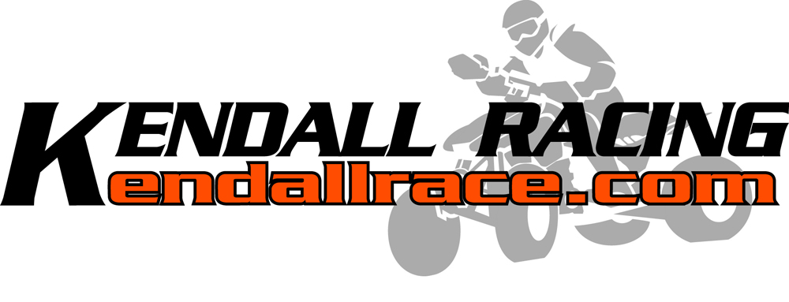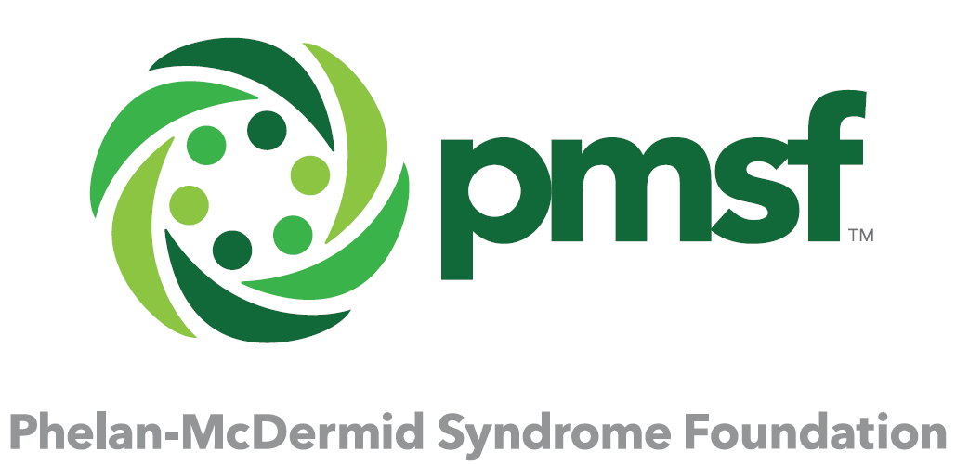
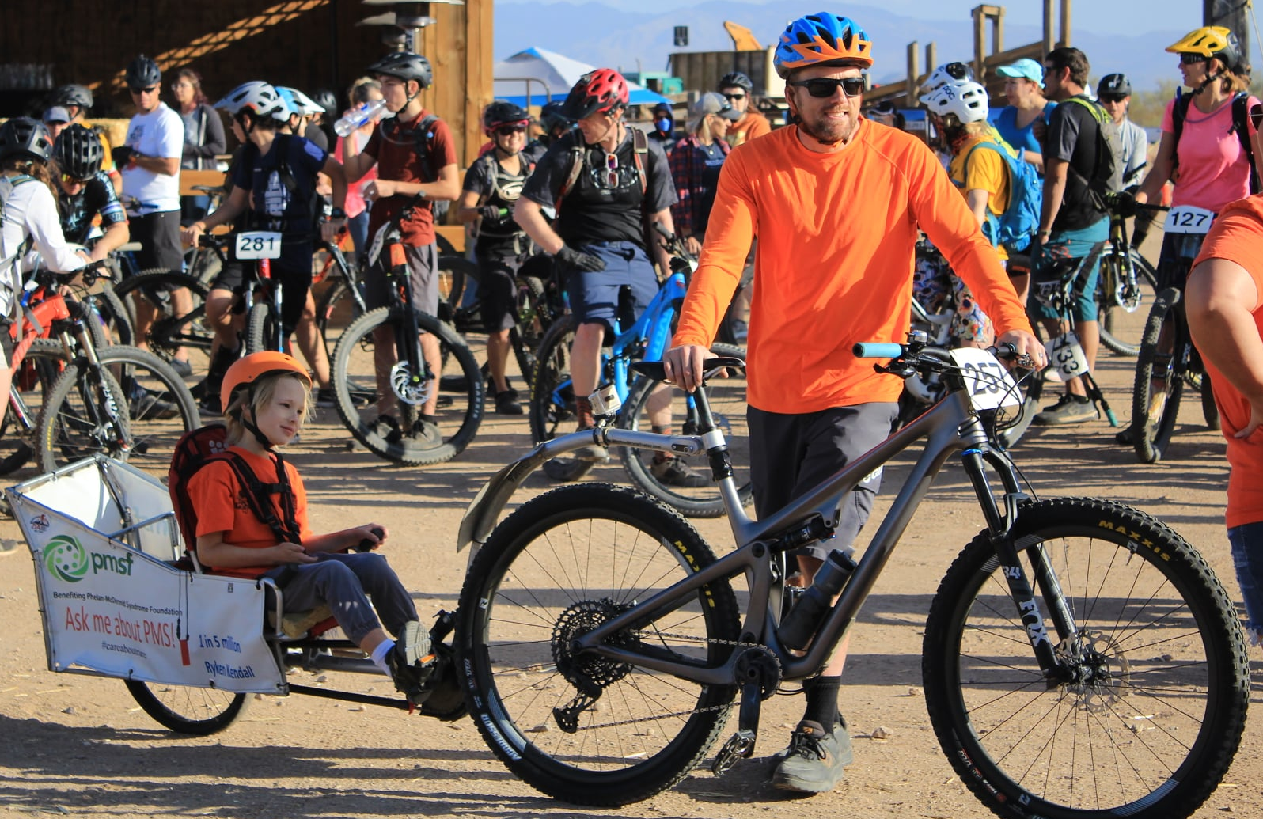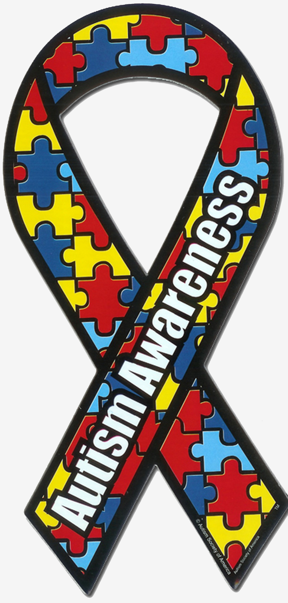
Trent Kendall (41 years old) and Ryken Kendall (7 years old)
Phoenix, AZ trelken@gmail.com Racing Class: Intermediate/Expert

ATTN: Sponsorship Department, 2020-2021 Electric Mountain Bike Sponsorship

Objective:
Obtain an electric full suspension mountain bike so I can continue to race with my son Ryken in his custom bike trailer to spread awareness about rare diseases. Ryken is 7 years old and has a 1 in 5 million rare genetic disorder called Phelan McDermid Syndrome. He is nonverbal and he loves people and riding. We have raced together for 18 months but he is getting too heavy for me to pull with human power alone. I want to continue to spread the word to the special needs community that these kids love doing things and biking is a great option.

I am confident this will be a big win for the generous company who can offer an electric bike because they will be featured in our stories and on our race banner that is displayed on the bike trailer which means their logo will be in all photographs. Everyone loves a feel good story especially one with a unique angle like this one. It is not common to see a lunatic towing a heavy trailer through the desert that contains a kid laughing all the way. The reaction will be even bigger at a WORCS race on a motocross track.

Highlights:
2019 Dawn to Dusk Fountain Hills, top 50% lap time while towing Ryken.
2019 Wickenburg Tour de Ranch Intermediate class winner (solo)
2020 Papago 6 hour top 25% Expert team finish (solo)
2020 Wickenburg Tour de Ranch Expert class, towing Ryken lap 1 and solo lap 2.
2019 Race photo was used for the cover of the Wickenburg Sun newspaper and “Destination Wickenburg” board of tourism magazine.
Background:
I raced cars for 6 years, then ATV’s in the professional class for another 10 years. I like to share my passion for sport with the world and this has resulted in my various websites and articles being published in magazines and books. While racing I was sponsored by many generous companies and I know how to conduct myself professionally while gaining exposure for my sponsors. After retiring from ATV racing in 2017 I started riding mountain bikes for fun and it has turned into my latest passion.

The largest off road racing series on the west coast, “WORCS” just launched an E-MTB category. They have confirmed they will allow me to race in their series with my son and I would like to enter these races while towing my son because I think it would get a lot of publicity for my son’s disorder and for the bike company who sponsors me.

Representation:
I will faithfully and respectfully represent your company on the track, the podium and online.

All of our race stories, sponsor info and other information will be posted and kept up to date on the comprehensive http://www.kendallrace.com website, YouTube page, Facebook, Twitter and Instagram.



